17th Annual
Hui Wa’a Kaukahi Kayak Club Papio Fishing Tournament
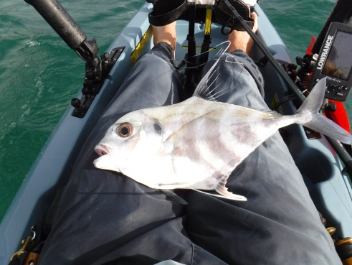
E n t r y F o r m
Saturday & Sunday, October 19th & 20th , 2019
5:00 a m to 2:00 p m

Kualoa Regional Park Campsite A

- Camping the night before is encouraged.
- The park gate closes at 8:00 p m and doesn’t open till 7:00 a m
- Prizes will be awarded for the biggest papio (10 pounds and under), Second biggest Papio, Third biggest Papio and the largest “other species”

Name:_________________________________________

Phone Number :_________________________________

Email Address:_________________________________

Entry fees: Club Members: $30
Others: $40

Please make your checks payable to “Hui Wa’a Kaukahi” and mail them to Windward Boats, Attn: Stan McCrea, 789 Kailua Road, Kailua Hawaii 96734.
You can also drop entry forms in person at Windward Boats Kayak department with Stan McCrea. Tech Geeks can PayPal Stan @ paypal.me/wawaenuiloa Make sure you send as a friend so no fees are taken out.

